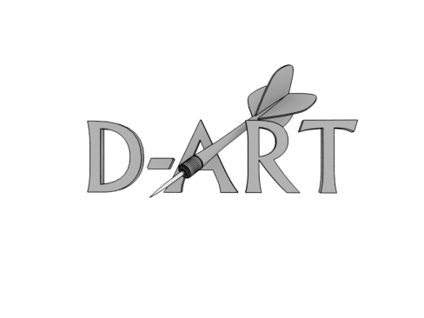
INtErnational Scientific conference
Linguistics of discourse:
on the crossroads of ideas and research traditions
IV International Round Table on Discourse Studies and Research (D-ART)
June 25-28, 2014
Place: Warmia and Mazury University in Olsztyn
Centre of Humanities (Poland)
Organization Committee:  Center of Eastern European Studies  UWM in Olsztyn  The Field Committee on Linguistics of Discourse of the International  Committee of Statists (FCLD of ICS)  Prof. (Hab.) Aleksander Kiklewicz  Prof. (Hab.) Irina F. Oukhvanova  Prof. (Hab.) Alina Naruszewicz-Duchlińska  Dr. Sebastian Przybyszewski  Dr. Iza Matusiak-Kempa  Jakub Michalczenia, manager  Address:  UWM w Olsztynie, Centrum Badań Europy Wschodniej  ul. Kurta Obitza 1  10-725 Olsztyn  Contact information:  akiklewicz@gmail.com  jakubmichalczenia@interia.pl  tel. ++ 48 602 175 802  ++ 48 513 384 789  The material of the conference will be published in a series of books La Table Ronde (ISSN 2218-8002) | Topics for discussion:  The conference continues the series of International Discourse-Analysis Round Tables (D-ART): the first one took place in 2009 in Minsk, Belarus, the second one in 2010 in Vilnius, Lithuania, and the third one in 2011 in Opole, Poland.  Linguistics of Discourse (Discourse Studies) is a new and actively developing perspective of linguistics and social sciences being implemented in both academic and research activities. The tasks which are on the agenda within Linguistics of Discourse is viewed within:  - integration of a discourse-focused research community from different perspectives — Communication Studies, Linguistics (both theoretical and applied), and Text Studies — and national traditions;  - search for conventions within codes and types of categorization of its research objects;  - theoretical modeling of research results.  The programme includes round tables (RT) and lecture presentation (LP) with further questions and discussion (LP):  - 1st day — (RT1) Linguistics of Discourse: content, methods within QUAL-QUAN traditions, variability of database presentation, research results in theoretical modeling; (RT2) Communicative Linguistics: content, methods, traditions; (RT3) New generation of research algorithms: postgraduates’ forum.  - 2-nd day — Lecture presentations and discussions within all three topics presented in the round tables of the first day.  - 3rd day — (RT1+2+3) Problems and benefits of integrating social and language studies and research: the future of the field.  - 4th day — (A) Meetings of the members of the FCLD of ICS in its strategic groups, the latest being (1) Theory and methodology of discourse linguistics: (2) Contrastive discourse studies; (3) Lexicographic representation of discourse linguistics; (4) Contemporary discourses; (5) Ancient discourses; (6) Discourse expertise; (7) Academic discourse and discourse approach in methodology of foreign language teaching; (8) Discourse linguistics for artificial intellect; (9) Translatorics and cross cultural communication; (10) Discourse studies in the context of corpus linguistics; (11) Neurolinguistic discourse studies: phonology, prosody, morph syntax (experimental laboratory studies); (B) International research project proposals, discussions, application work.  Working languages: English and Slavic languages.
Conference expenses are at the participants’ cost. The conference fee is 550 PLN (135 Euro). It includes lunches and coffee breaks (June 25-27), hotel accommodations at the university village Kortowo, conference dinner and publication.  The deadline for sending applications is  January 30, 2014. The form for application  is attached. |  | Conference takes place in Polish town Olsztyn, in the Campus of Warmia and Mazury University. This is the most beautiful university campus on the territory of which there are, besides university buildings and its library, two lakes, forest-like park, stadium, swimming pool, stable and manege, stores and clubs.
Application
Name, surname, degree, position:

Affiliation (work/study):

Presentation topic:

Presentation abstract:

Email:
Bank information

Equipment necessary for presentation AV:

……………………………………….
Signature

